**CHECKLIST FOR MANUAL LATE AND ABSENCES ADJUSTMENT**

**PAYROLL PERIOD: SEP11 SEP25 – AMC2024**

* 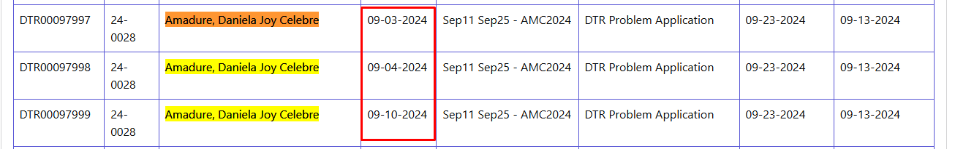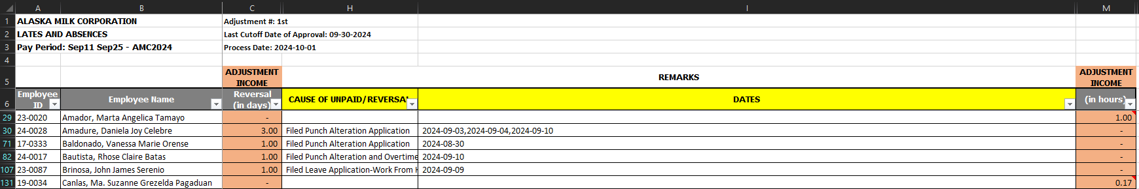Manual Adjustment (She has DTRP in September 3, 4 and 10)
* Attendance Processing (automate) Aligned with the Manual
* Baldonado, Vanessa Marie Orense - Aligned with the Manual



* Bautista, Rhose Claire Batas - Aligned with the Manual

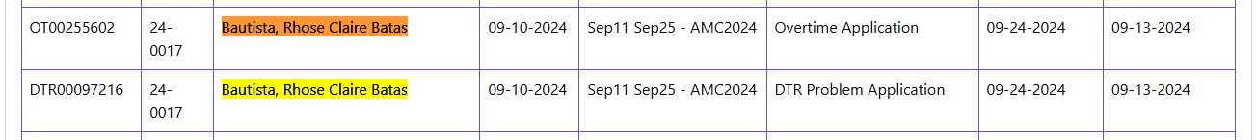



* Brinosa, John James Serenio - Aligned with the Manual





* Canlas, Ma. Suzanne Grezelda Pagaduan – No Records of Late / Undertime Can’t find in Automate Adjustment Processing the employee has a late/undertime of 0.12 in Sep 3
* Casipit, Nino Paterno Quintos - Aligned with the Manual

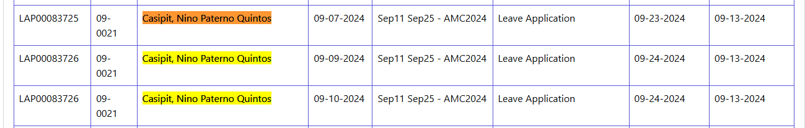

* Collo, Mary Katherine Ane Agar – No Records of Late / Undertime (0.60) on Sep 4
* Ilmedo, Wally Lizarda - Aligned with the Manual

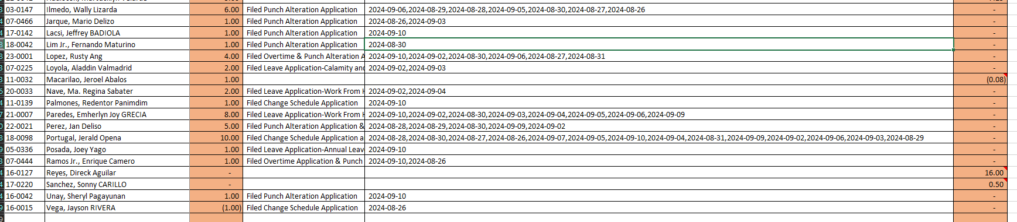

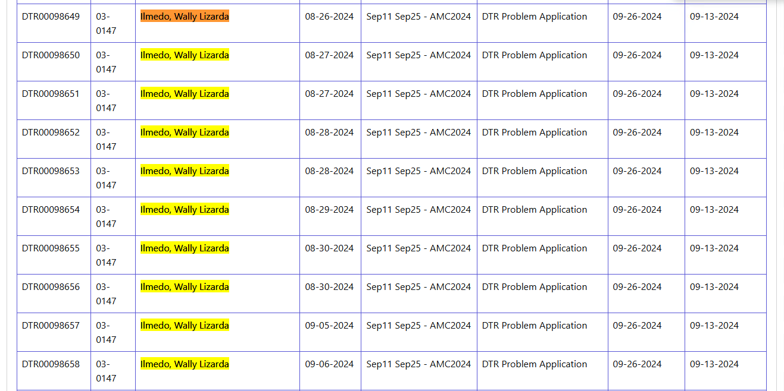

* Jarque, Mario Delizo - Aligned with the Manual



* Lacsi, Jeffrey BADIOLA - Aligned with the Manual



* Lim Jr., Fernando Maturino - Aligned with the Manual



* Lopez, Rusty Ang - Aligned with the Manual

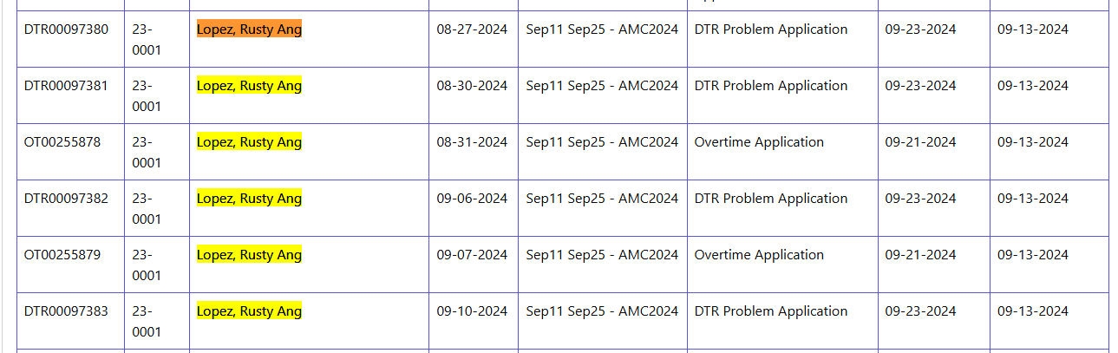

* Loyola, Aladdin Valmadrid - Aligned with the Manual

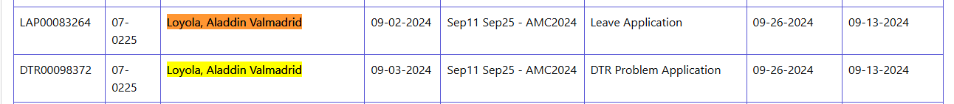

* Nave, Ma. Regina Sabater - Aligned with the Manual

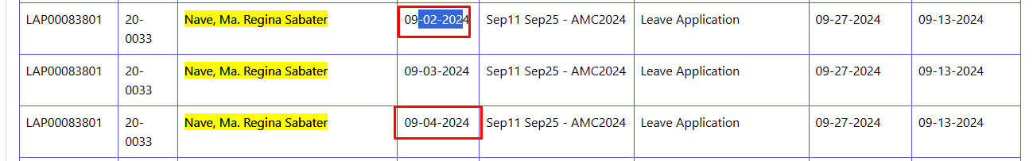

* Palmones, Redentor Panimdim